NOTES FOR CAPTAINS 2025/26 #4

DUTY UMPIRING
CALLING NO BALLS

Please pass this on to all your players who will be undertaking duty umpiring.

MCC Law 21.10 Ball bouncing over head height of striker

The umpire shall call and signal No ball for any delivery which, after pitching, passes or would have passed over head height of the striker standing upright at the popping crease.

NOTE: NOT to be called a Wide
Square leg umpires to assist in calling no ball.

MCC Law 41.7.1

Any delivery, which passes or would have passed, without pitching, above waist height of the striker standing upright at the popping crease, is unfair. Whenever such a delivery is bowled, the umpire shall call and signal No ball.

LIMITATIONS OF ON SIDE FIELDERS

Some duty umpires are calling “no-ball” when there are more than five (5) fielders on the on side (leg side)

MCC Law 28.8 regarding limitations of on side fielders:

“At the instant of the bowler’s delivery there shall not be more than two fielders, other than the wicketkeeper, behind the popping crease on the on side. A fielder will be considered to be behind the popping crease unless the whole of his/her person whether grounded or in the air is in front of this line.
In the event of infringement of this Law by any fielder, the striker’s end umpire shall call and signal No ball.”
The regulation limiting five fielders on the on side is a SSJCA regulation and has no application in SSCA Matches

FREE HIT – ONE DAY MATCHES ONLY

    - When No ball has been called, and neither batter is out under Playing Conditions clause 34 (Hit the ball twice), clause 37 (Obstructing the field) or clause 38 (Run out) the next legal delivery bowled shall be a free hit for whichever batter is facing it.
    - For any free hit, the striker can be dismissed only under the circumstances that apply for a No ball, even if the delivery for the free hit is called Wide.
    - Neither field changes nor the exchange of individuals between fielding positions are permitted for free hit deliveries unless:
    - There is a change of striker or
    - The No ball was the result of a fielding restriction breach, in which case the field may be changed to the extent of correcting the breach.
    - For clarity, the bowler can change his/her mode of delivery for the free hit delivery. In such circumstances clause 21.1 shall apply.
    - The umpires will signal a free hit by (after the normal No ball signal) extending one arm straight upwards and moving it in a circular motion.

LEGSIDE WIDE – ONE DAY MATCHES GRADES 1 & 2 ONLY.

To a batter standing in their normal batting position, if a ball passes outside the legside wide guidelines as marked between the batting and popping creases the umpire shall call Wide.
Clarifying Note: any ball which passes between the leg stump and a point 12 inches from the centre of middle stump will not be deemed a wide.
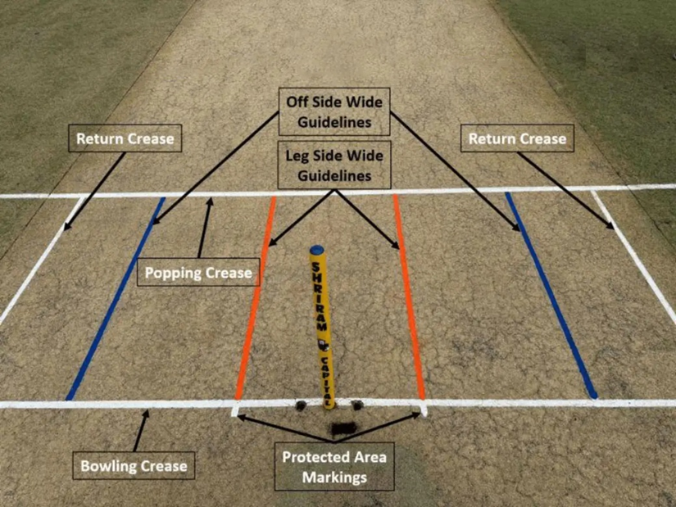

Michael Mooney
Secretary
5 September 2025

