Sutherland Shire Cricket Association Inc.
(ABN 99 793 660 400)
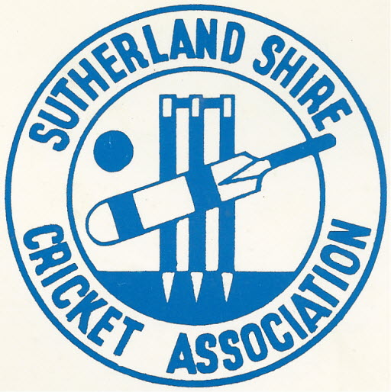
President: Kevin McGrath
Secretary: Michael Mooney
33 Dolans Road
WOOLOOWARE NSW 2230

email beachcombers@iprimus.com.au
phone: 0409 031 583

76th Adjourned Annual General Meeting
17th July 2023

Meeting commenced at 7:34 pm

Meeting chaired by Kevin McGrath (President SSCA)

Welcome by Chairperson

Apologies

Neil Croker, Adam Pascoe, James Young, Dwayne Cocks.

Proxies

Gymea Bay CC 8 proxies held by Ian Gatherer
Gymea Bay CC 1 proxy held by Andrea Handley
Cronulla Seagulls CC 5 proxies held by Michael Mooney

Attendees

Committee: Kevin McGrath, Warren Dess, Michael Mooney, Mitch Reidy, Andrea Handley, Allan Lofthouse, Matt Berkley, Col Hobman.

Delegates: Greg Barnett (Como Jannali), Brendan Cantlon (Cronulla Seagulls), Matthew Carroll (Engadine Dragons), Brett Handley (Gymea Bay), Ian Gatherer (Gymea Bay), Mark Easton (Miranda Magpies), Matt Thomas (St John Bosco), Mitch Worsley (St John Bosco), Dan Porter (St John Bosco), Guy Briguglio (St John Bosco), Warren Daley (St Patrick’s), Adam Harkin (Loftus).

- Team Nomination Forms (SSCA proposal)

Template has been drafted and will be distributed to Clubs.
- Clubs should add as question to their registration forms on PlayHQ.
- Team names - Must be Club Captains name or initials + Grade requested - not "nick names”.
- All players at a minimum - grade last played.
- Statistics must be provided for any player who scores 150 runs + and /or took 10 wickets.

2. SSCA Fees (SSCA proposal)

To provide assistance to Clubs for late registrations throughout season the SSCA will introduce the following registration cost thresholds:
Full Season Registration: Up to & Including Round 7 $75.00
Mid-Season Registration: Registrations after Round 7
but before Christmas $50.00
End of Season Registration: Post Christmas $35.00
Junior Permit to play in seniors (Clubs to be invoiced) $35.00

3. Assistance to reduce risk of Teams playing short (SSCA proposal).

- Two-day Match Player Numbers
Teams will be able to nominate 14 players for 2-day matches.
Any 11 bat and any 11 bowl (including wicketkeepers) provisions remain.

Playing Condition 43.2.1 changes required:

43.2 Player nominations
43.2.1 Up to 14 players may be nominated on the team sheet exchanged prior to the commencement of the match.
43.2.2 Up to 11 players may bat or bowl in any given innings. As per the Laws, no more than 11 players may field at any given time.

Clarifying Note: For the purposes of this Playing Condition, the wicketkeeper at the start of play is considered to be a ‘bowler’.

- Players Playing Down

Nominations:
- To be nominated in Team Nomination Form (in the column provided)
- Clubs can nominate as many players as they choose to play down.
- Late nominations (throughout season) to be requested in writing by Thursday night @ 7:00pm for approval.
- Saturday morning requests will not be considered.

Restrictions:
- Players can only play no more than 2 grades lower than their original grading i.e. A1 player approved to play down could play as low as B1 (Assuming A1, A2, B1, B2,B3,B4, B5, C1)
- Limit of 4 matches for playing down
- Semi Finals and Finals are excluded from playing down provisions i.e., players cannot play down in a Semi or Final
- Ability to play in semi's / finals does not change and is based on the players original grade i.e., they can play in their original grade or higher but NOT down.

- Players Playing Up (SSCA proposal)

• Increase allowance from 2 matches to 4 matches (regraded to higher grade after playing 4th game).
Initially accepted.
NOTE: This provision was later changed by Delegates to 5

d. Late Registrations

- Must be submitted via PlayHQ & written notification to Competition Manager, Secretary & Treasurer no later than 7:00pm Thursday evening prior to the start of a round.
- PlayHQ processing places this limitation in advising SSCA of registration and payment.
- Players are not covered until financial, and insurances cleared which can take up to 2 days via PlayHQ
- No option to allow players to play unless fully cleared (Legal liability)
- Saturday morning requests are not an option.

e. Junior to Senior Permits

- Already in place through Play HQ – typical turn around 1 – 2 days
- $35 fee invoiced to Clubs – their option on recharging to players/families

4. SSCA Fees (SSCA proposal)

Discussion around rationale for maintain fees at $75.00 for full time players whilst having equity of about $98,713

SSCA discussion paper attached.

5. Forfeit Fines - Schedule 3 – Fines and Penalties (SSCA proposal)

- Increased assistance has been provided to Clubs and Teams to provide more flexibility on making up team numbers.
- Junior Permits
- 5 Match Play up and 4 Down provisions.
- Late Registration fee reductions
- Late registration provisions (existing)

• Penalties, while not the preference, are necessary and are in place to ensure some responsibility on Club, Teams, and Players to get minimum number required to have a match – forfeits affect / hurt all teams in the competition not just the one forfeiting.

Proposed Change(s):

That the fine for forfeiting a match first occurrence be changed from $50.00 to $100.00 plus all match fees and umpire’s fees as applicable.
Moved Allan Lofthouse Seconded Andrea Handley
In favour: 26
Against: 8
MOTION CARRIED

That the fine for forfeiting a match second and subsequent occurrence be changed from $100.00 to $150.00 plus all match fees and umpire’s fees as applicable.
Moved Allan Lofthouse Seconded Andrea Handley
In favour: 26
Against: 8
MOTION CARRIED

6. One day Matches changed to 35 overs per side.

- One day Matches changed to 35 overs per side for all grades.
Moved Ian Gatherer Seconded Matt Berkley
In favour: 6
Against: 28
MOTION DEFEATED

- One day Matches changed to 35 overs per side for top 4 grades only (A1 / A2 / B1 / B2 grades).
Moved Ian Gatherer Seconded Matt Berkley
In favour: 10
Against: 24
MOTION DEFEATED

7. Two-day Matches changed to 50 overs per side.

- Two-day Matches changed to 50 overs per side for all grades.
Moved Mark Easton Seconded Michael Mooney
In favour: 1
Against: 33
MOTION DEFEATED

- Two-day Matches changed to 50 overs per side for all grades below the top 4 grades. The top 4 grades (A1 / A2 / B1 / B2 grades) continue to play 60 overs.
Moved Mark Easton Seconded Michael Mooney
In favour: 2
Against: 32
MOTION DEFEATED

7. Dedicated T20 / 100 grade(s)

Motion : That some grades be dedicated to T-20 or 100 ball matches
In favour: 2
Against: 32
MOTION DEFEATED

Discussion as to whether 5 team competitions could comprise 4 x 2 game matches / 4 x 1-day matches / 4 x T-20 matches
To be considered by Management Committee after teams have been nominated and graded.

8. To change the number of games a player can play in a higher grade before re-grading to 5 games.

Motion: Where a player plays up for a 5th time that player is graded in that team for remainder of season.
In favour: 25
Against: 9
MOTION CARRIED
NOTES:
• Once regraded after playing up 5 matches a player cannot then apply to play down in a lower grade.
• In EXCEPTIONAL CIRCUMSTANCES if a Club wants a player considered for regrading back down – a written request must be may by Club Secretary no later than 7:00pm Thursday evening prior to the start of a round.

By Law 3.3.2 changes required:
• Amend By-Law 3.3.2
A player who participates in more than four matches in a grade higher than that in which they are registered, will automatically be considered to have been re-graded in the grade in which they played the fifth match.

Meeting closed 8:57pm

Michael Mooney Kevin McGrath
Secretary President

